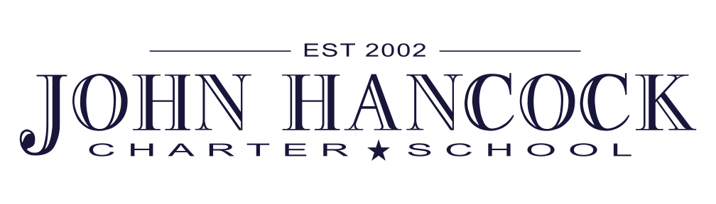

Board Meeting, October 30 2014

Pledge

Prayer

Parent Comments

PTO Update

Parent Advocate Update

Approval of 2 June and 18 June 2014 Minutes

Appointment of New Board Chair

Director Update on SAGE Testing

Audit Committee Update and Review of the Audit

Finance Update

Title I Discussion and Possible Approval

First Reading of Title I Parent Involvement Policy

UCA Approval

First Reading of Integrated Pest Management Policy